CIS2058-N Assessment Test Plan
Apex
Carl Baines
Name: Carl Baines
Module: Web Apps & Services
Date: 14/12/2025
Tutor Name: Tyrone Davison

Contents
Test Plan 1

Test Plan

TEST ID | Requirement | test type | test description | input | expected output | result | notes
1 | Web Services (Apex.Catering) to create, edit, delete and list food items - see the ERD above for details; | VALID | Create a Food Item | POST /api/PostFoodItem  Body: {"itemName":"Chicken Curry","description":"Mild curry","unitPrice":6.50} | 201/200; response includes foodItemId; item persists | 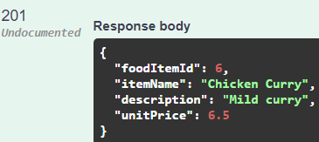 | N/A
2 | Web Services (Apex.Catering) to create, edit, delete and list food items - see the ERD above for details; | VALID | List Food Items | GET /api/FoodItems | 200; returns list including new item | 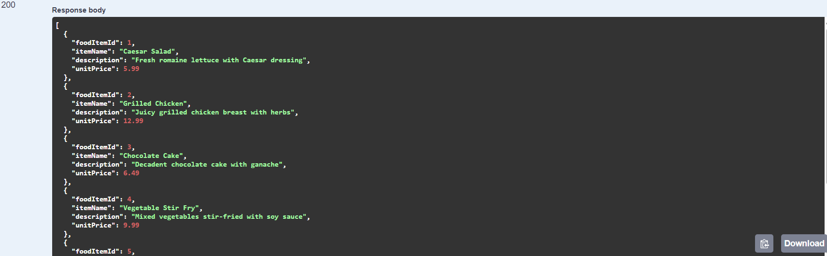 | N/A
3 | Web Services (Apex.Catering) to create, edit, delete and list food items - see the ERD above for details; | VALID | Edit a Food Item | PUT /api/PutFoodItem/{foodItemId}  Body: {"foodItemId":<id>,"itemName":"Chicken Curry","description":"Spicy curry","unitPrice":7.00} | 204/200; subsequent GET shows updated values | 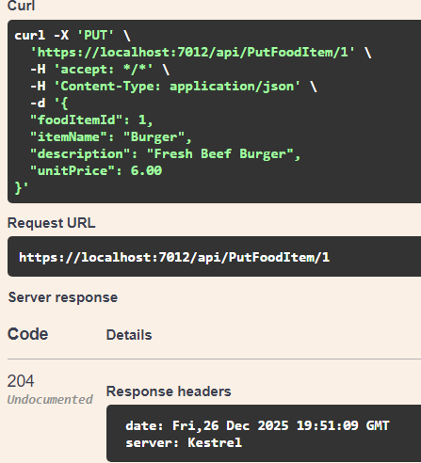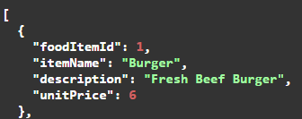 | N/A
4 | Web Services (Apex.Catering) to create, edit, delete and list food items - see the ERD above for details; | VALID | Delete a Food Item | DELETE /api/DeleteFoodItem/{foodItemId} | 204/200; subsequent GET by id returns 404 | 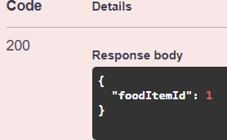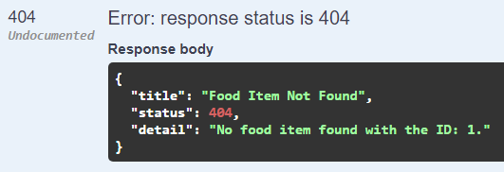 | N/A
5 | Web Services (Apex.Catering) to create, edit, delete and list the details of food Menus - see the ERD above for details; | VALID | Create a Menu | POST /api/PostMenu  Body: {"menuName":"Standard Buffet"} | 201/200; response includes menuId; menu persists | 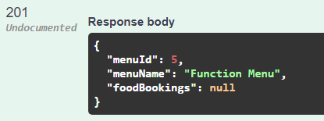 | N/A
6 | Web Services (Apex.Catering) to create, edit, delete and list the details of food Menus - see the ERD above for details; | VALID | List Menus | GET /api/GetMenu | 200; returns list of menus | 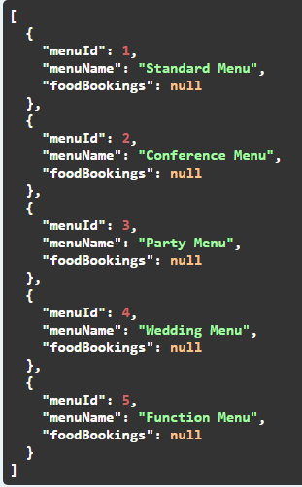 | N/A
7 | Web Services (Apex.Catering) to create, edit, delete and list the details of food Menus - see the ERD above for details; | VALID | Edit a Menu | PUT /api/PutMenu/{menuId}  Body: {"menuId":<id>,"menuName":"Premium Buffet"} | 204/200; subsequent GET shows updated values | 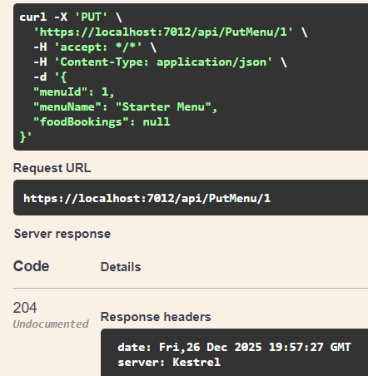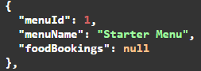 | N/A
8 | Web Services (Apex.Catering) to create, edit, delete and list the details of food Menus - see the ERD above for details; | VALID | Delete a Menu | DELETE /api/DeleteMenu/{menuId} | 204/200; subsequent GET by id returns 404 | 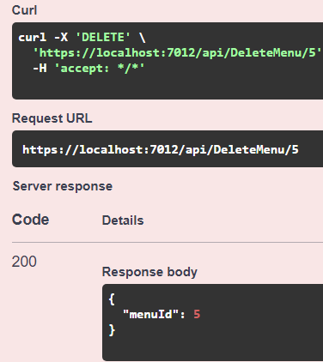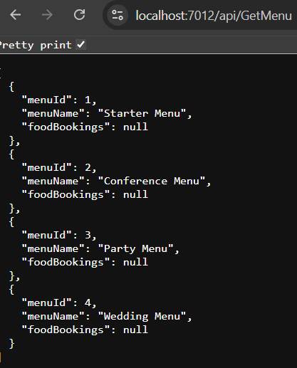 | N/A
9 | Web Services (Apex.Catering) to add and remove a food item from a menu - see the ERD above for details; | VALID | Add Food Item to Menu | POST /api/PostMenuFoodItem  Body: {"menuId":<menuId>,"foodItemId":<foodItemId>} | 201/200; association created | 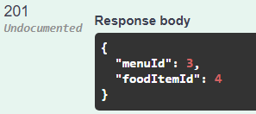 | N/A
10 | Web Services (Apex.Catering) to add and remove a food item from a menu - see the ERD above for details; | VALID | Remove Food Item from Menu | DELETE /api/DeleteMenuFoodItem/{menuId}/{foodItemId} | 204/200; association removed | 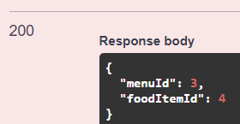 | N/A
11 | Web Services (Apex.Catering) to book, edit and cancel Food for an Event - see the ERD above for details. The service should return the FoodBookingId as confirmation of the booking; | VALID | Book Food for an Event and confirm FoodBookingId returned | POST /api/FoodBookings  Body: {"eventId":<existingEventId>,"menuId":<menuId>,"numberOfGuests":50,"clientReferenceId":12345} | 201; response includes foodBookingId confirmation | 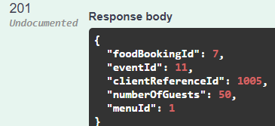 | N/A
12 | Web Services (Apex.Catering) to book, edit and cancel Food for an Event - see the ERD above for details. The service should return the FoodBookingId as confirmation of the booking; | VALID | Edit Food Booking for an Event | PUT /api/FoodBookings/{foodBookingId}  Body: {"foodBookingId":<id>,"eventId":<existingEventId>,"menuId":<menuId2>,"numberOfGuests":60,"clientReferenceId":12345} | 204/200; subsequent GET shows updated values | 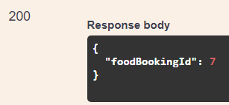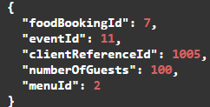 | N/A
13 | Web Services (Apex.Catering) to book, edit and cancel Food for an Event - see the ERD above for details. The service should return the FoodBookingId as confirmation of the booking; | VALID | Cancel Food Booking for an Event | DELETE /api/FoodBookings/{foodBookingId} | 204/200; subsequent GET returns 404 (or shows cancelled if implemented) | 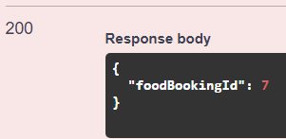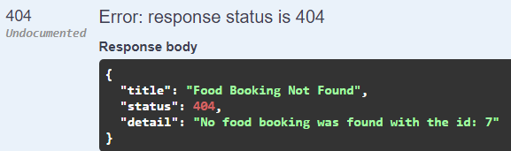 | N/A
14 | Create a new Event, specifying as a minimum its title, date and EventType; | VALID | Create a new Event | UI: Events > Create  Title: Winter Gala  Date: 2026-01-15  EventType: Conference  Venue: select any available | Event created; appears in Events list | 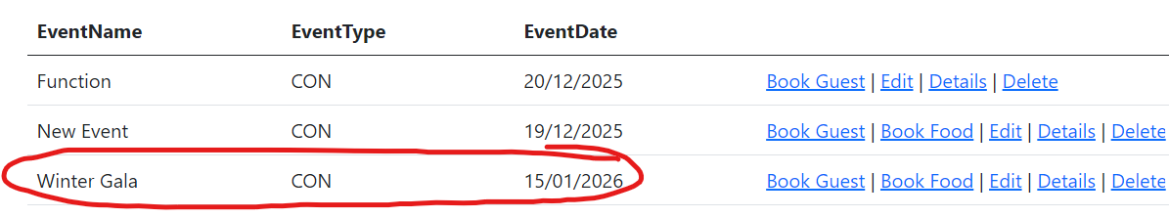  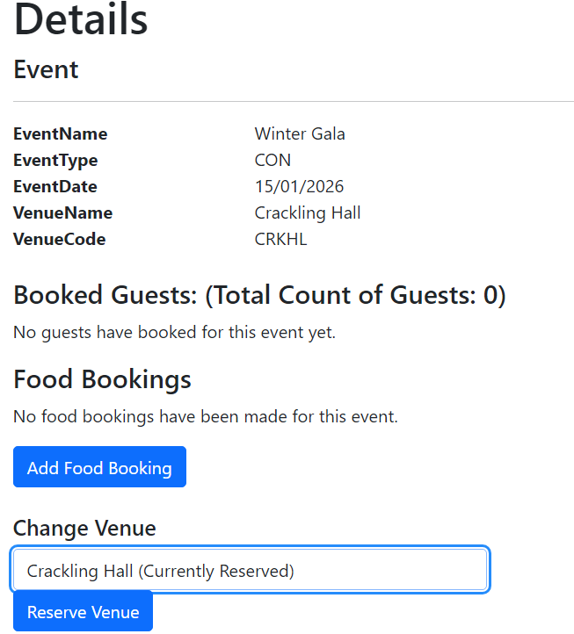 | N/A
15 | Create a new Event, specifying as a minimum its title, date and EventType; | INVALID | Create Event with missing required field(s) | UI: Events > Create  Leave Title or Date or EventType blank | Validation shown; event not created | 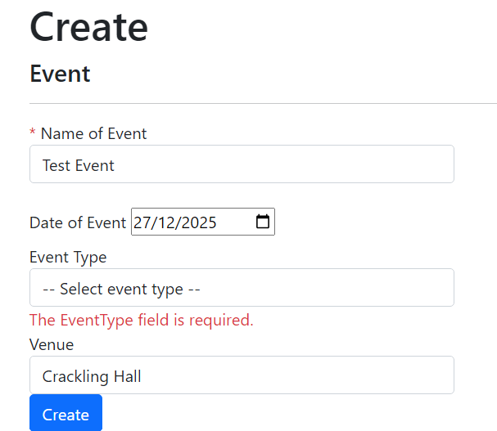 | N/A
16 | Create, list and edit Guests; | VALID | Create Guest | UI: Guests > Create  First: Ava  Last: Singh  Email: ava@example.com | Guest created; appears in Guests list | 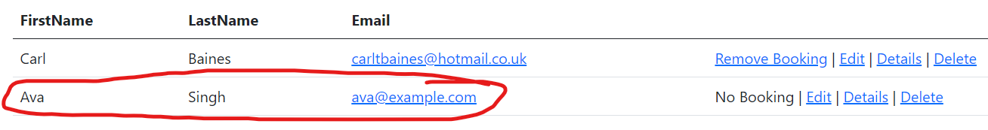 | N/A
17 | Create, list and edit Guests; | VALID | List Guests | UI: Guests > Index | Guests list displayed including new guest | 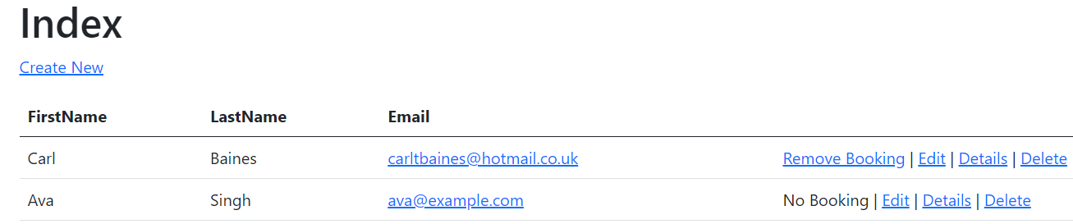 | N/A
18 | Create, list and edit Guests; | VALID | Edit Guest | UI: Guests > Edit  Change LastName to Patel | Guest updated; list/details reflect change | 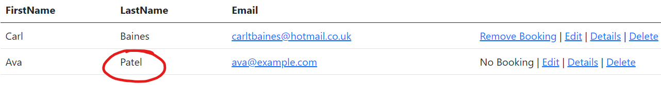 | N/A
19 | Book (add) a Guest onto an Event; | VALID | Book a Guest onto an Event | UI: Events > BookGuest (from Event)  Select Guest <guestId> | Booking created; guest appears under Event guest list | 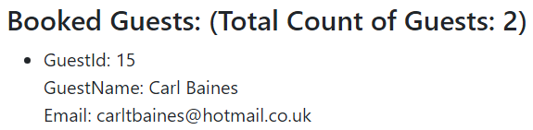 | N/A
20 | Book (add) a Guest onto an Event; | INVALID | Prevent duplicate guest booking (negative) | Attempt to book same Guest to same Event twice | Duplicate prevented; user shown error or no duplicate created | 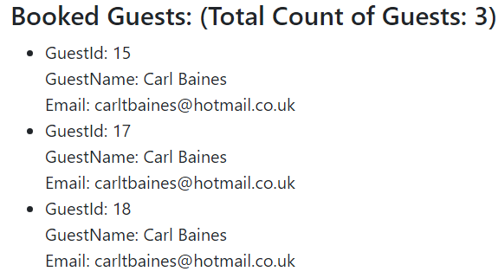  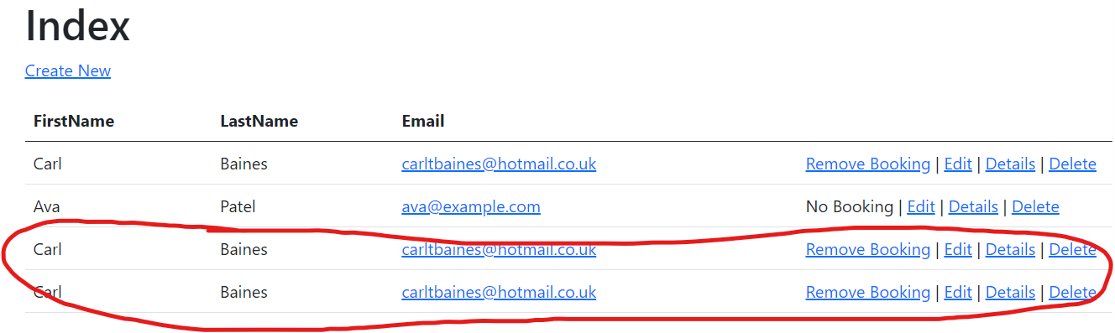 | Unintended behaviour – need to add some logic which retrieves the current list of booked guests for an Event and checks against the posted booked guest for duplicates. It also seems to have added new guests to the guests index page weirdly.  (FIXED)
21 | List Guests for an Event including a total count of guests; | VALID | List guests for an Event and verify total count | UI: Events > Details for event with 3 guest bookings | Guest list shows 3 guests; total count displayed as 3 | 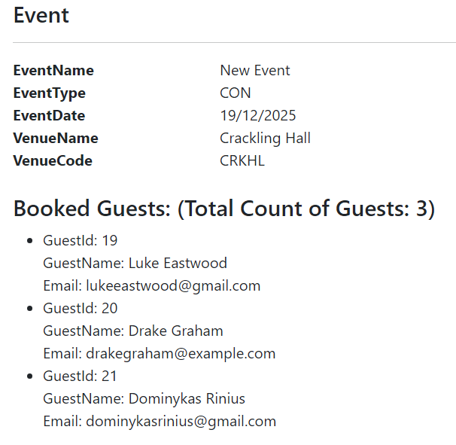 | When booking a guest onto an Event, it doesn’t actually fetch the Guests list to check whether the posted Guest actually exists. You can post a guest that is not on the guest list.
22 | List Guests for an Event including a total count of guests; | VALID | Event with zero bookings shows count correctly | UI: Events > Details for event with 0 bookings | Guest list empty/empty state; total count displayed as 0 | 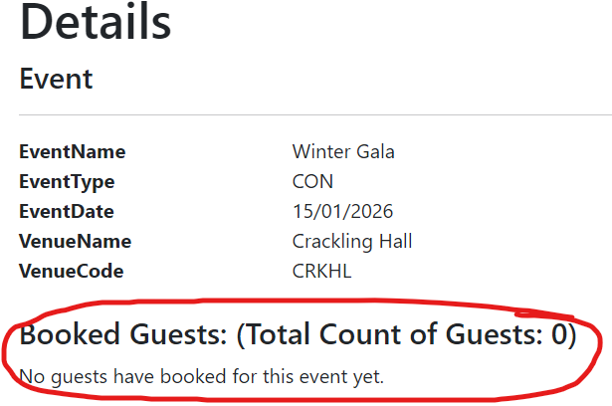 | N/A
23 | Register guest attendance for an Event; | VALID | Register attendance for a booked guest | UI: Guests > Details  Tick attendance checkbox for booked event; click Register Attendance | Attendance saved; revisit shows attending = true | 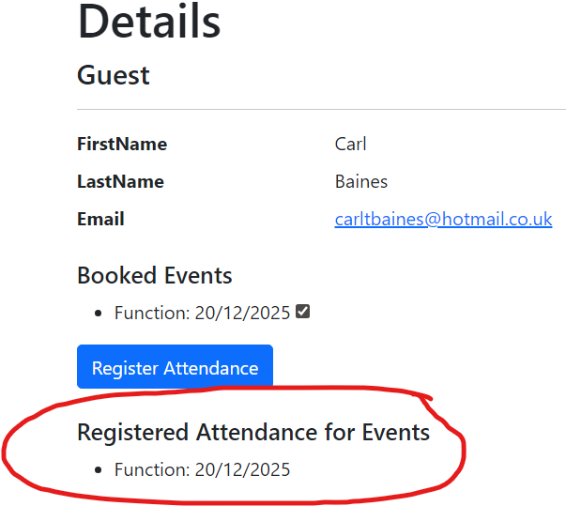 | N/A
24 | Register guest attendance for an Event; | VALID | Unregister attendance (toggle off) | UI: Guests > Details  Untick checkbox; click Register Attendance | Attendance saved; revisit shows attending = false | 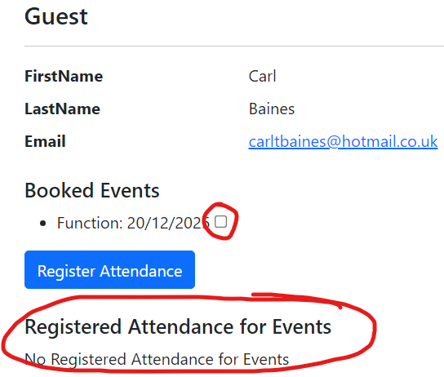 | N/A
25 | Display the details of a Guest, including information about the Events with which they are associated and their attendance; | VALID | Guest details shows associated Events + attendance | UI: Guests > Details for guest with bookings | Details lists events and attendance per event | 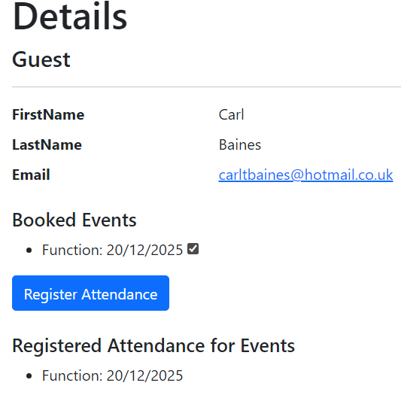 | N/A
26 | Edit an Event (except its date and type); | VALID | Edit Event (allowed fields only) | UI: Events > Edit  Change Title to Winter Gala 2 | Title updated; date/type unchanged | 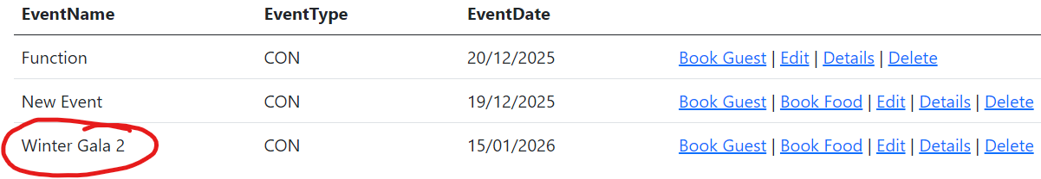 | N/A
27 | Edit an Event (except its date and type); | INVALID | Ensure date/type cannot be edited (or changes ignored) | UI: Events > Edit (date/type read-only) | Date/type unchanged; only permitted fields update | 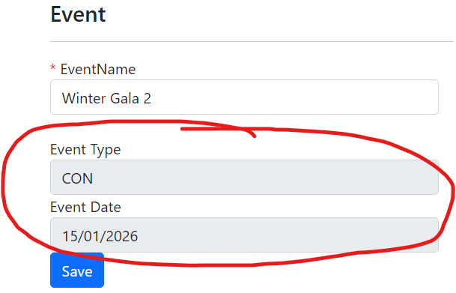 | N/A
28 | Cancel (remove) the booking of a Guest from an upcoming Event; | VALID | Cancel (remove) guest booking from upcoming Event | UI: Guests > RemoveGuestBooking  Select booking for future-dated event; confirm remove | Booking removed; guest no longer listed for event | 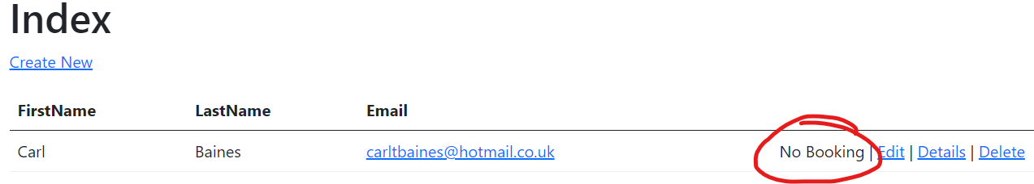  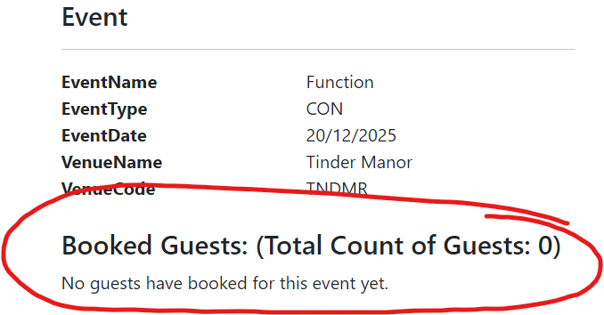 | N/A
29 | Reserve an appropriate, available Venue for an Event via the Apex.Venues web service, freeing any previously associated Venue; | PLANNED | Reserve available Venue for an Event | UI: Event Details > Reserve Venue  Select an available venue code | Venue reserved via Apex.Venues service; event shows reserved venue
30 | Reserve an appropriate, available Venue for an Event via the Apex.Venues web service, freeing any previously associated Venue; | PLANNED | Change venue reservation frees previous venue | UI: Reserve venue A then reserve venue B for same event | Event shows venue B; venue A becomes available again
31 | Display a list of Events that includes summary information about the Guests and Venue within it | VALID | Events list shows guest count + venue summary (implemented) | UI: Events > Index  Precondition:  - At least 2 events exist  - Event A has 0 guests booked  - Event B has 3+ guests booked  - Each event has a selected Venue value (from Create Event). | Events Index shows, per event row:  - Venue summary (e.g., venue name/code)  - Guest summary (e.g., guest count)  Counts match the number of bookings per event.
32 | Create, list and edit Staff; | VALID | Create Staff | UI: Staffs > Create  First: Sam  Last: Taylor  Role: Team Leader | Staff created; appears in staff list | 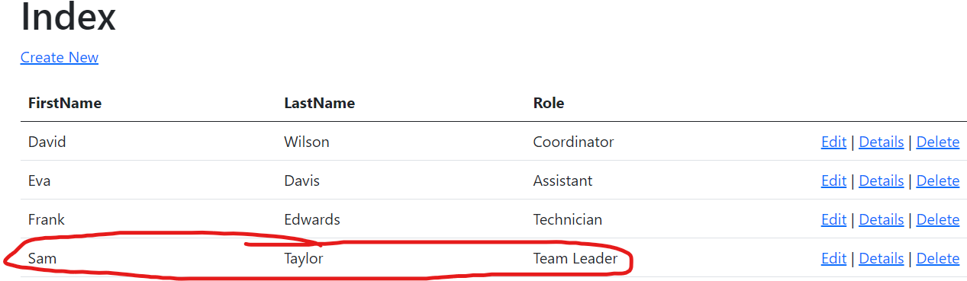 | N/A
33 | Create, list and edit Staff; | VALID | List Staff | UI: Staffs > Index | Staff list displayed | 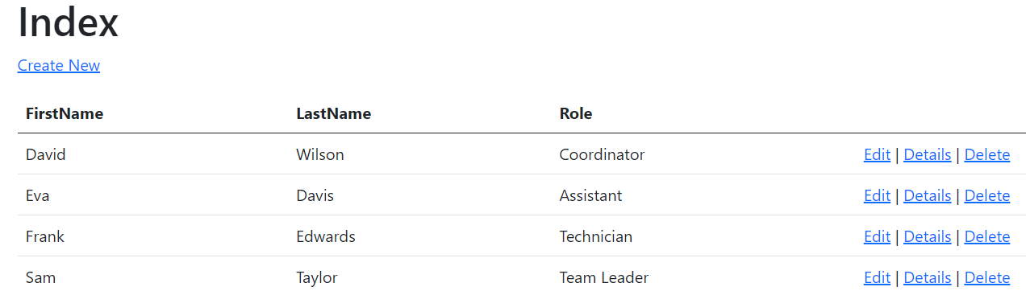 | N/A
34 | Create, list and edit Staff; | VALID | Edit Staff | UI: Staffs > Edit  Change Role to Manager | Staff updated; list/details reflect change | 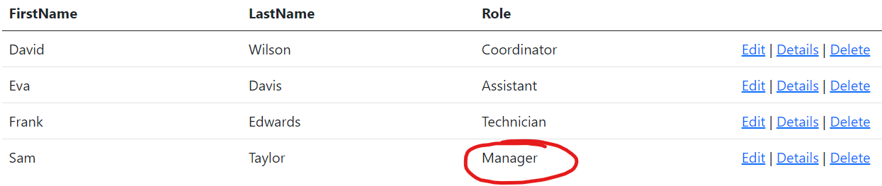 | N/A
35 | Adjust the staffing of an Event, adding available staff or removing currently assigned staff; | VALID | Add available Staff to an Event | Precondition: Staff members exist.  UI: Events > Details > Add Staff Member + Assignment Name  Action: Assign an available staff member to the event and save. | Staff assignment is saved.  The Events Details page shows the assigned staff member.  Staff Details page lists the event under upcoming assigned events (if future-dated). | 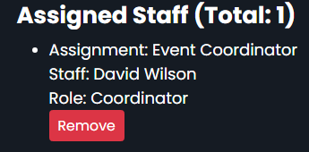 | N/A
36 | Adjust the staffing of an Event, adding available staff or removing currently assigned staff; | VALID | Remove assigned Staff from an Event | Precondition: Event has at least 1 assigned staff member.  UI: Events > Events Details > Remove Button under designated staff member.  Action: Remove/unassign the staff member and save. | Staff assignment is removed.  The Events Details page no longer lists that staff member.  Staff Details no longer lists that event as an upcoming assignment. | 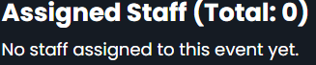 | N/A
37 | See appropriate warnings within event list and staffing views when there is not a first aider assigned to an Event; | VALID | Warning shown when no first aider assigned | Precondition: Event has assigned staff but NONE flagged as first aider.  UI: Events > Index AND Events Details Page> Assigned staff view for that event. | A clear warning is displayed in:  - Events Index (event list)  - Events Details page assigned staff view  indicating that no first aider is assigned to the event. | 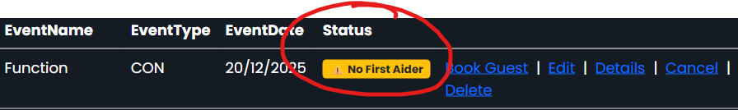  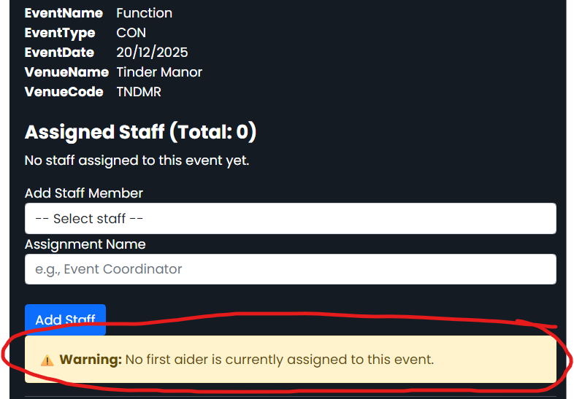 | N/A
38 | Display the details of a Staff member, including information about upcoming Events at which they are assigned to work; | VALID | Staff details show upcoming assigned events | Precondition: Assign this staff member to at least one future-dated event.  UI: Staffs > Details for the staff member. | Staff Details lists upcoming events the staff member is assigned to (title/date). | 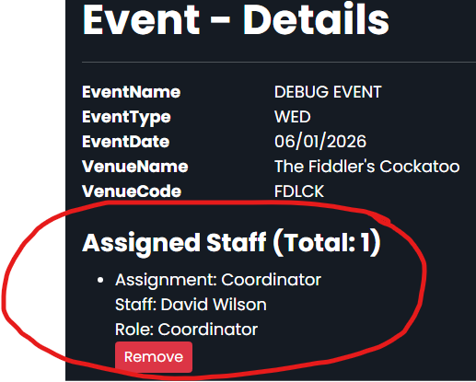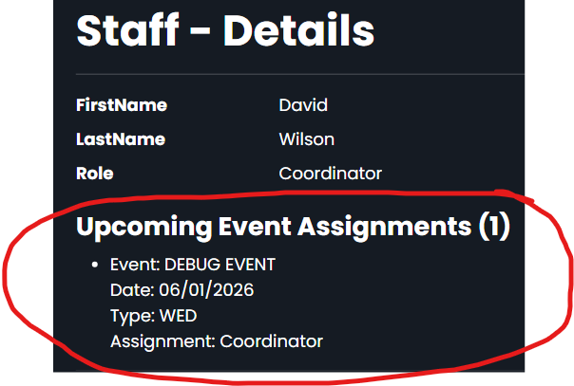 | N/A
39 | Cancel (soft delete) an Event, freeing any associated Venue and Staff; | VALID | Cancel (soft delete) Event and free associated Staff | Precondition: Future-dated event has assigned staff.  UI: Events > Details (or Index) > Cancel/Soft Delete action.  Confirm cancellation. | Event is marked cancelled (soft deleted) and removed from active event lists (or clearly labelled cancelled).  All staff assignments to the event are removed.  Staff Details pages no longer list the cancelled event as an upcoming assignment. |  | N/A
40 | Display the details for an Event, which must include details of the Venue, Staff and Guests – this should be more detailed that the summary information found in the Event list; | PLANNED | Event Details includes Venue, Staff and Guests (more detail than list) | UI: Events > Details for event with venue/staff/guests | Details shows venue + staff + guests and is more detailed than Index summary | 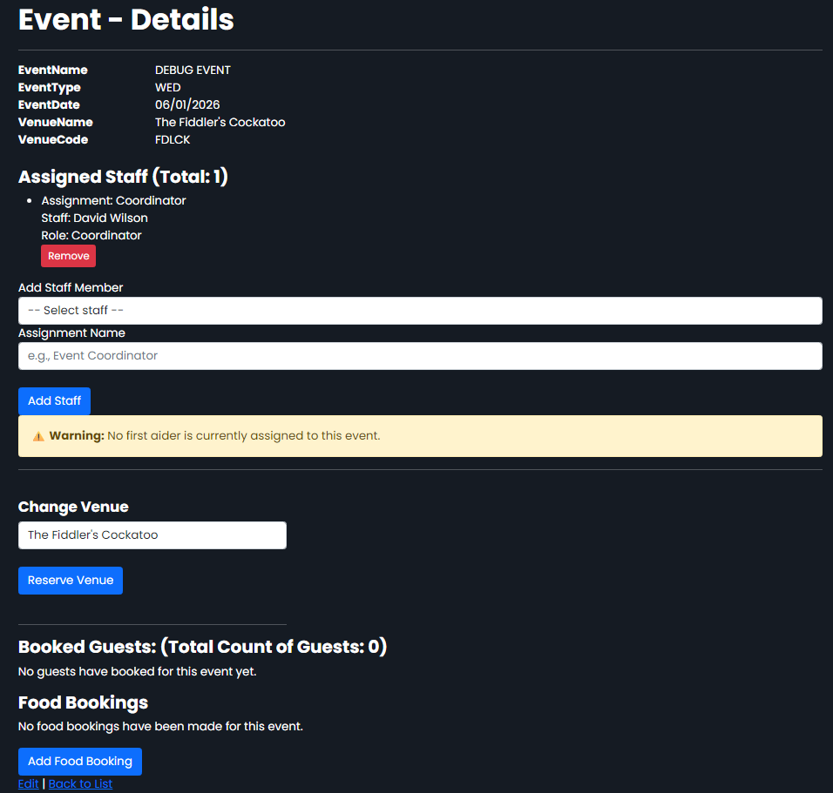 | N/A
50 | Create a new Event, specifying as a minimum its title, date and EventType; | INVALID | Create Duplicate Event | UI: Events > Create  Select duplicate event name, event date, event type. | Validation shown;  Event not created | 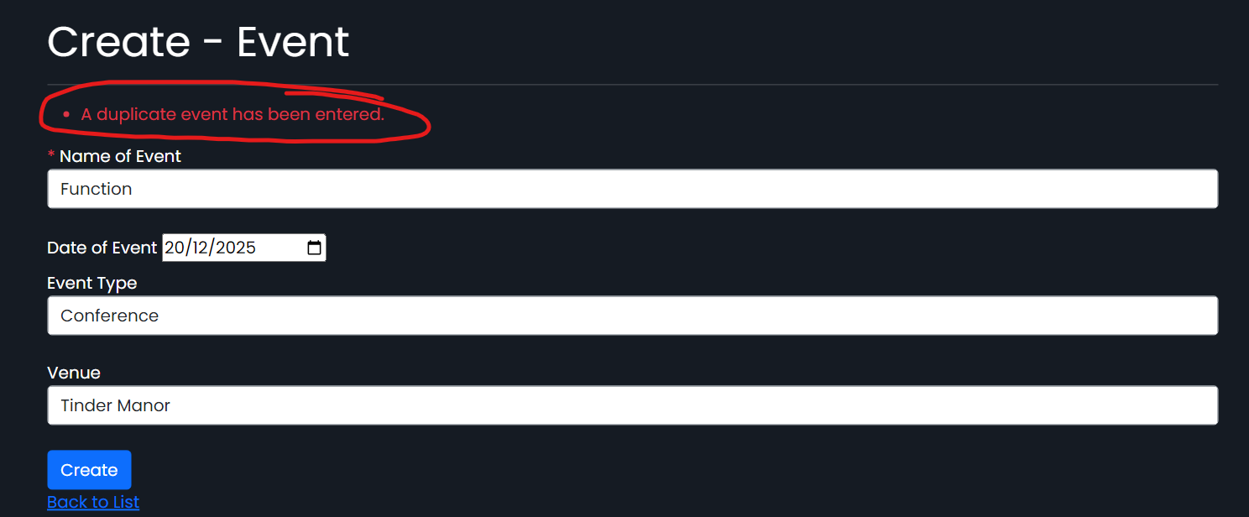 | N/A
51 | Create, list and edit Guests; | INVALID | Create Duplicate Guest | UI: Guests > Create  Select duplicate guest first name, last name and email. | Validation shown;  Guest not created | 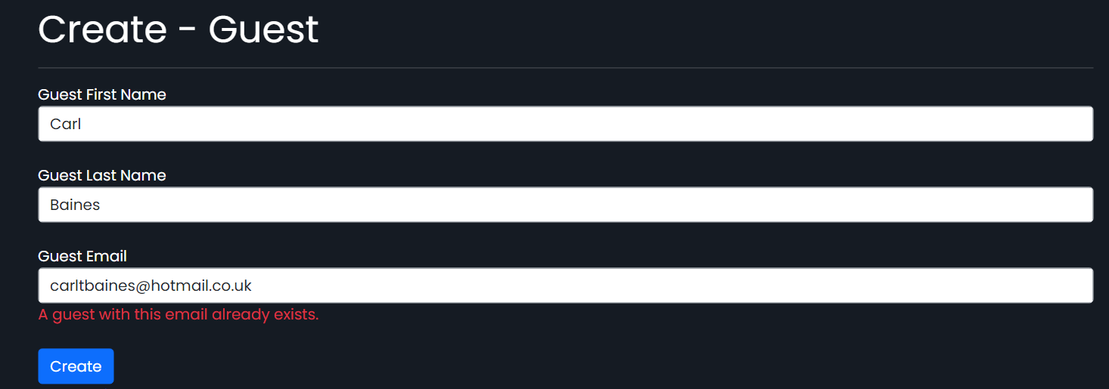 | N/A
52 | Create, list and edit Staff; | INVALID | Create Duplicate Staff Member | UI: Staff > Create  Select duplicate staff first name, last name and role. | Validation shown;  Staff member not created | 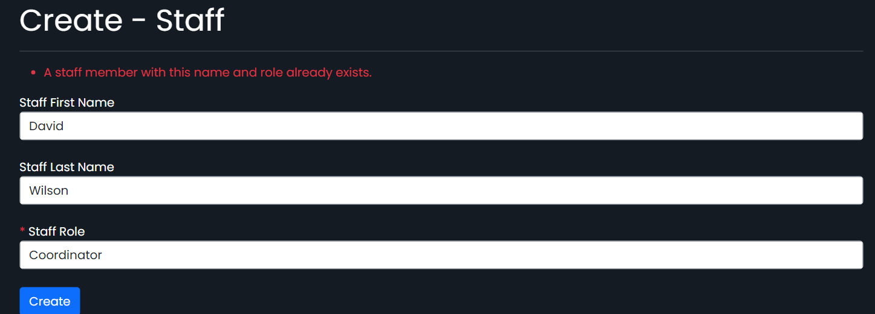 | N/A

